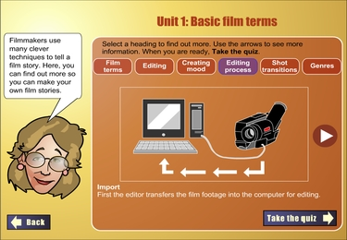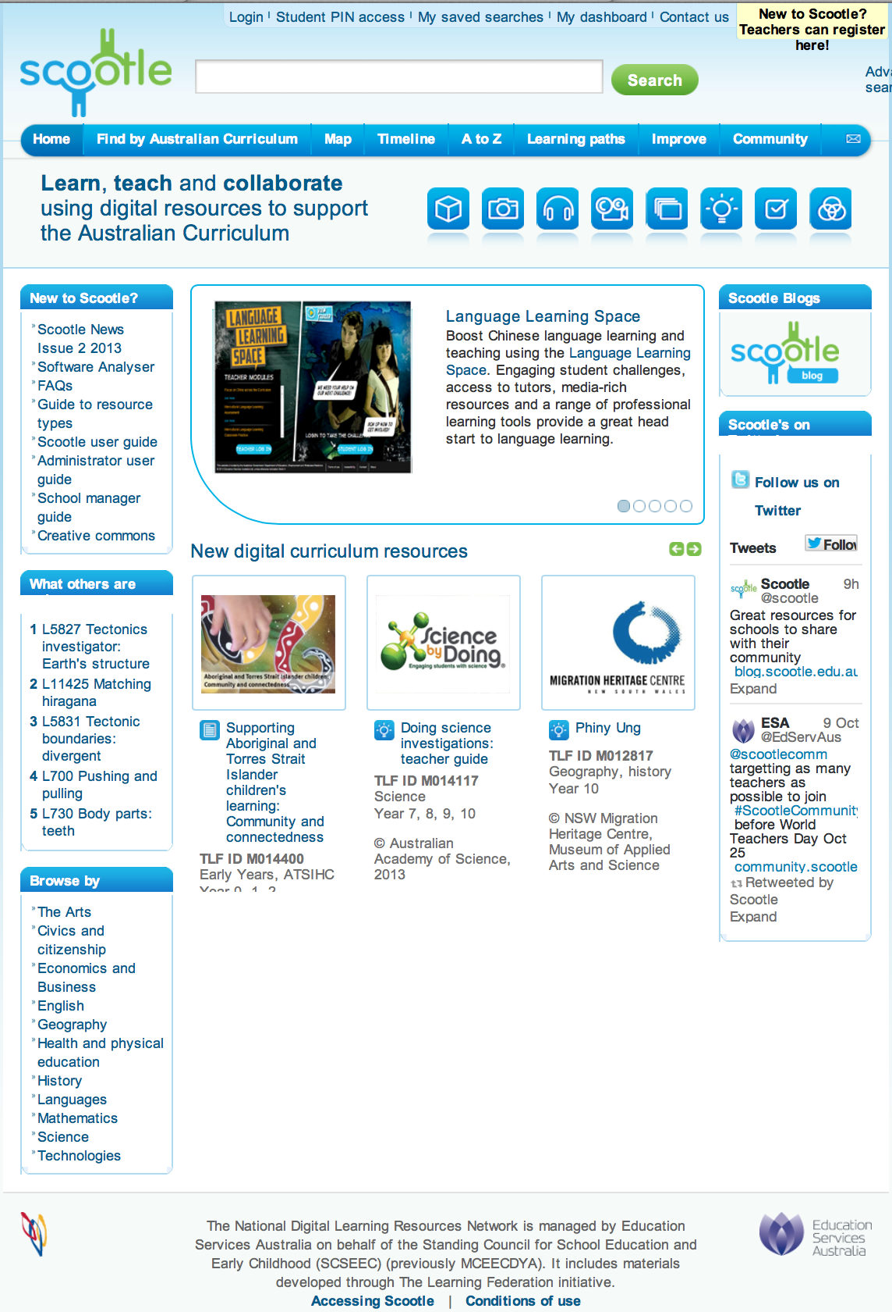

L2845

**LEARNING PATH:** A teacher logs in, browses and selects materials to add to a personalized list of resources for their students. This list is called a “Learning Path”. It means that teachers can tailor what they provide for their students.

Instructions or questions can be added to each item on a Learning Path, so it could become the basis of a project, an assessment or a homework task tat students can do at their own speed.

**RESOURCE INFORMATION** includes resource Type, Key Learning Objectives, Educational Value, Year Level, Topics, Learning Area, + strand, Rating, ideas for further defining the search, etc. Similar resources are also suggested.

Searched resources can be **VIEWED** on the page in a variety of ways, depending on how much information you need. SAMPLE the resources and check the suitability for your students before adding to a Learning Path.

**BROWSE TOPICS** (by curriculum area on the Home screen. Inside the database this facility provides good clues for the sorts of search words you might use if you are having trouble thinking of search words.

**SEARCH** for resources.

Use a single word or the ADVANCED search, which provides filters like year level, curriculum area, topic, type of resource…

**RELATED TOPICS** lists often help broaden a search or give good ideas for ways to use a topic as a springboard for other topics or content.

**NEW RESOURCES** in the Scootle stable.

**RESOURCE CODE**: every Scootle resource has a unique code. If you know the code (e.g. you saw it on an Australian Curriculum document) then use it as the search word.

**HOW TO**…. For new members.

The SOFTWARE ANALYSER is useful for checking whether your computer has the right plug-ins for these resources.

**SOCIAL MEDIA** links and information.

Advertising related educational **PROFESSIONAL LEARNING OPPORTUNITIES** like conferencees, journals, network groups, other resource libraries…

**EDUBLOGS** has a Scootle blog site with related information

**KINDS OF RESOURCES AVAILABLE** are interactives (like flash-based games), images, audio files, videos (most can be downloaded), pre-organised collections of resources on “big topics”, teaching ideas (often lesson plans or thematic ideas), assessments (like multi-choice Qs and often match other resources) and data-sets (statistics and database files).

**REGISTER HERE** if you have not received a Scootle registration log-in email from the Scootle manager at your school.

It’s not an “instant join”. It puts you in touch with the Scootle Manager for your school jurisdiction. They organise a Scootle Manager at school level. This person usually disseminates Scootle registration info (by email) to staff. Uni students and others non school based people can join but need to use the “others” contact info.

**WAYS TO SEARCH** the resources database … or access IMPROVE (making assessments) and COMMUNITY (social networking feature)

**STUDENTS ACCESS RESOURCES** that teacher place in a “Learning Path” (LP) by entering the PIN that was generated when the teacher created the LP. **Students do NOT need to register.** The PIN is their access code.

**TEACHER LOG-IN** to access the content. You can only do this after going thru the registration process. Your username will be your school email (usually an “edu.au” address).